CRYSTAL MEET 2024

Licence No: 3WL240610

Level 3 Event

Under FINA Technical Rules & Swim Wales Laws

Sunday 3rd March 2024

At Waterworld Leisure & Activity Centre
LL13 8DH

Under FINA Technical Rules and Swim Wales Laws
Sunday 3rd March 2024
This is a Level 3 Licenced Meet
VENUE: | Waterworld Leisure & Activity Centre, Holt Street, LL13 8DH.
POOL: | 25m, 6 lane deck level pool with anti-turbulence lane ropes and starting blocks with adjustable footrests and backstroke start wedges.
TIMING: | Electronic timing with manual back up in the event of breakdown.

AGE GROUPS: 9, 10, 11, 12, 13, 14, 15 yrs/over
(Age on the day of the Meet – Minimum age on day of swim 9 years)

EVENTS: | Girls/Boys 9/10yrs | 50m all strokes plus 100 I.M.
 | Girls/Boys 11yrs | 100m all strokes plus 100m I.M.
 | Girls/Boys 12yrs | 100m all strokes plus 100m I.M.
 | Girls/Boys 13yrs | 100m all strokes plus 200m I.M.
 | Girls/Boys 14yrs | 100m all strokes plus 200m I.M.
 | Girls/Boys 15yrs/over | 100m all strokes plus 200m I.M.

MEET CONDITIONS

ENTRIES | All competitors must be members of an affiliated club, amateurs as defined by Swim Wales or the ASA Laws and hold a valid Swim Wales/ASA membership number.  There are no qualification, upper limit or cut of times for this Meet, which comply with meet licensing.  Where possible entries should be submitted electronically using the Hy-tek Team Manager software and emailed to: sian.bostock@gmail.com).  Alternatively, entries can be made manually using the attached proforma on page 11, however please note that the entry fees are less if entered electronically.  No refunds will be made for withdrawals after the closing date other than on medical grounds. A medical note must be provided.
ENTRY FEES | Entry Fees for each event is £6.50 for an electronic entry or £7.00 for a manual entry per event.
Electronic Payment is preferred:
Wrexham Swimming Club
Sort Code: 40-16-02
Account Number: 01857061
Reference: SPR followed by your Club’s code
Please confirm your payment by emailing sian.bostock@gmail.com
CLOSING DATE | Closing date for entries is 18th February 2024. Entries are on a first received, first entered basis. Please note that Wrexham Swimming Club reserve the right to close entries earlier than the advertised closing date, if the total number of swimmers allowed poolside is reached.  Entries received after this date cannot be guaranteed for consideration, unless it is a mistake on our part.
MEDAL/AWARDS | Medals are awarded to all six finalists in each individual age group.
Crystal Awards for top Girl and Boy in each individual age group.

 | Please note that medals will be presented throughout each session and will be handed out to the relevant coaches. The Crystal Awards will be presented at the end of the Meet. We reserve the right to change how the medals are distributed based on Covid restrictions at the time.
SESSION TIMES | Session Times and Warm-Up Schedule will be confirmed once all entries have been processed.
 | Participating Clubs will receive notification of final meet details and session times prior to the event.
 | Whilst we will make every effort to adhere to the published programme of events, Wrexham Swimming Club reserve the right to make any changes found necessary during the Meet.
SEEDING | All events will be swum in heats, slowest to fastest, with every heat being spearheaded. All events are Heat Declared Winner.
STARTS | Over the top starts, where necessary or appropriate, will be used during this Meet.  Swimmers must have attained the standard of the Competitive Start Award in order to start from the blocks; this is the responsibility of the club coach.  Swimmers who have not attained the standard of the Competitive Start Award must lower themselves over the side into the water, on the long whistle of the Referee before starting at an appropriate place.
COACH PASSES | Coaches passes are £10, to include programmes and results sheets. Please confirm how many coach passes on the live entry file set-up for this meet. We will then ensure it is included in your invoice.
 | Poolside access will be restricted to competitors, officials and coaches with passes. All poolside adults must have a completed DBS with their affiliated club.
 | Poolside access will be restricted to competitors, officials and coaches with passes.
It is the responsibility of the visiting clubs to make sure all Coaches/Team Managers who will be poolside are DBS checked.

OFFICIALS | In order to be able to run a successful Meet we need Visiting Clubs to provide officials.  For those Clubs entering the Meet with between 5 and 9 swimmers, we are requesting that you provide a minimum of 1 official (J1T standard or above) per session, whilst those Clubs entering with more than 10 swimmers are requested to provide a minimum of 2 qualified officials (J1 standard or above) per session.
We will provide parking refunds, a donation towards lunch for any officials helping with 2 or more sessions. This refund can be claimed after the gala by completing the expense claim form provided.
Please note that we use Swim Meet to help organise officials for our Galas. Swim Meet allows officials to tell us what session they are available for, put in any special requests e.g. specific jobs etc. and if for whatever reason officials become unable or wish to change the session there are officiating in, they can simply go back to the link and make the change. By using Swim Meet it makes the process much clearer and easier for everyone involved.
Swim Meet can be accessed at this link: https://www.swimmeet.com/Availability/
MARSHALLING | Swimmers must make themselves available to marshalling at least 2 events prior to their event. Please do not rely on the public address system for announcements.
SPECTATORS | £6.50 entry per adult for all of the day or £4.00 per session. Children enter for free.  Wrexham Swimming Club reserve the right to make changes to spectating based on Covid regulations.
CAR PARKING | There is ample car parking spaces around the Centre, with long stay parking, within easy walking distance.
REFRESHMENTS | There is a café on site. There are also vending machines in the Centre and local shops/supermarkets in close vicinity of the Centre available for food and refreshments.
JEWELLERY | Wrexham Swimming Club will not be responsible for any jewellery brought to events and will not be liable if such jewellery is lost or damaged. All Valuables/clothing etc left in the changing areas will be entirely at the owner’s risk.

UNACCEPTABLE BEHAVIOUR

Behaviour becomes “unacceptable” when it is considered “Offensive” to others; this includes, but is not limited to, the following:
Theft, wilful damage to property and / or equipment, acts of vandalism, abuse of alcohol and / or drugs, bullying, offensive language, aggressive / violent acts, threatening behaviour, all breaches of safety practices, failure to comply with instructions / directions, actions that bring the sport of swimming into disrepute.

Please note that changing on Poolside is considered inappropriate and therefore not permitted. Any swimmer seen to be changing on Poolside will be asked to move immediately to the designated changing areas at the Centre.
MOBILE PHONES | Mobile phones must not be used in the changing areas at the Centre. Any swimmer using phones in this area or having them on display will be reported to their coaches and removed from the Meet.
PHOTOGRAPHY | This competition involves children under the age of 18 years of age it is a mandatory meet license requirement that all persons (including competitors / officials / volunteers / spectators), wishing to engage in any kind of photographic activity including video, zoom, close range photography, irrespective of the nature of the device / equipment used for taking / recording such images must register their details with the event management in advance of taking any images.
 | People wishing to register their details may be asked to provide proof of identity.
HEALTH & SAFETY | The health, safety and wellbeing of all swimmers, officials, volunteers, spectators and visitors is paramount – all Health and Safety rules / regulations/ requirements must always be complied with.
 | A full risk assessment will be carried out in accordance with the Swim Wales Meet License Report Pack.

A copy of the Pool Operating Procedures and / or the Normal Operating Procedures & Emergency Action Plan for the Centre has been obtained in advance and will be available throughout the duration of Meet.

All swimmers, officials, volunteers, spectators, and visitors are required, at all times, to abide by the rules set out in the Centre’s Pool Operating Procedures and / or the Normal Operating Procedures & Emergency Action Plan.

PROGRAMME OF EVENTS
Session: 1
Round |  |  | Event
Finals |  | 1 | Girls 9-10 100 IM
Finals |  | 2 | Boys 9-10 100 IM
Finals |  | 3 | Girls 11-12 100 IM
Finals |  | 4 | Boys 11-12 100 IM
Finals |  | 5 | Girls 13-14 100 Backstroke
Finals |  | 6 | Boys 13-14 100 Backstroke
Finals |  | 7 | Girls 15 & Over 100 Breaststroke
Finals |  | 8 | Boys 15 & Over 100 Breaststroke
Finals |  | 9 | Girls 9-10 50 Freestyle
Finals |  | 10 | Boys 9-10 50 Freestyle
Finals |  | 11 | Girls 11-12 100 Breaststroke
Finals |  | 12 | Boys 11-12 100 Breaststroke
Finals |  | 13 | Girls 13-14 100 Freestyle
Finals |  | 14 | Boys 13-14 100 Freestyle
Finals |  | 15 | Girls 9-10 50 Backstroke
Session: 2
Round |  |  | Event
Finals |  | 16 | Boys 9-10 50 Backstroke
Finals |  | 17 | Girls 15 & Over 100 Butterfly
Finals |  | 18 | Boys 15 & Over 100 Butterfly
Finals |  | 19 | Girls 13-14 200 IM
Finals |  | 20 | Boys 13-14 200 IM
Finals |  | 21 | Girls 9-10 50 Butterfly
Finals |  | 22 | Boys 9-10 50 Butterfly
Finals |  | 23 | Girls 15 & Over 200 IM
Finals |  | 24 | Boys 15 & Over 200 IM
Finals |  | 25 | Girls 11-12 100 Backstroke
Finals |  | 26 | Boys 11-12 100 Backstroke
Finals |  | 27 | Girls 9-10 50 Breaststroke
Finals  Session: 3 |  | 28 | Boys 9-10 50 Breaststroke
Round |  |  | Event
Finals |  | 29 | Girls 11-12 100 Butterfly
Finals |  | 30 | Boys 11-12 100 Butterfly
Finals |  | 31 | Girls 13-14 100 Breaststroke
Finals |  | 32 | Boys 13-14 100 Breaststroke
Finals | 33 |  | Girls 15 & Over 100 Freestyle
Finals | 34 |  | Boys 15 & Over 100 Freestyle
Finals | 35 |  | Girls 11-12 100 Freestyle
Finals | 36 |  | Boys 11-12 100 Freestyle
Finals | 37 |  | Girls 13-14 100 Butterfly
Finals | 38 |  | Boys 13-14 100 Butterfly
Finals | 39 |  | Girls 15 & Over 100 Backstroke
Finals | 40 Boys 15 & Over 100 Backstroke

QUALIFICATION TIMES/UPPER LIMIT/CUT OFF TIMES
There is no qualification, upper limit or cut of times for this Meet.

WREXHAM SWIMMING
Crystal Meet: Sunday 3rd March 2024 – Club Entry Form Manual Entry
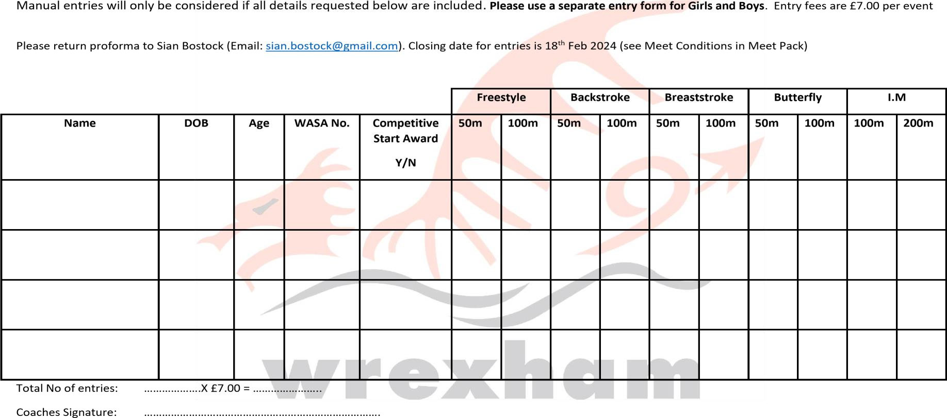
CLUB ____________________

